CPU Scheduling Comparison Project Documentation
This document presents the implementation and comparison of three CPU scheduling algorithms: Round Robin (RR), Shortest Job First (SJF), and Shortest Remaining Time First (SRTF). The project compares all three algorithms using the same workloads and evaluates their performance using scheduling metrics such as Waiting Time (WT), Turnaround Time (TAT), and Response Time (RT).

Team Information

Member Name | Student ID
ابراهيم محمد اسماعيل عبدالعزيز بحيري | 20240011
احمد حسام الدين محمد ابراهيم عبدربه | 20240027
عبدالرحمن ياسر سمير ابراهيم | 20240566
حبيبه محمد محسن زكي | 20240282
نوران طلعت عبدالمنعم | 20241073
اسراء محمد عبدالحكيم | 20240127

Algorithms Used
Round Robin (RR):
Round Robin distributes CPU time fairly between processes using a fixed time quantum. Each process receives a small portion of CPU time before the scheduler switches to the next process.
Shortest Job First (SJF):
SJF selects the process with the shortest burst time first. It improves efficiency and usually reduces average waiting time.

Scheduling Metrics
- Waiting Time (WT) = Turnaround Time - Burst Time
- Turnaround Time (TAT) = Completion Time - Arrival Time
- Response Time (RT) = First Start Time - Arrival Time

Test Scenarios

Scenario A - Normal Workload
This scenario demonstrates normal execution using multiple processes with different arrival and burst times.
Quantum = 2
P1 Arrival = 0 Burst = 5
P2 Arrival = 1 Burst = 3
P3 Arrival = 2 Burst = 4 Result:SRTF achieved the lowest waiting time.

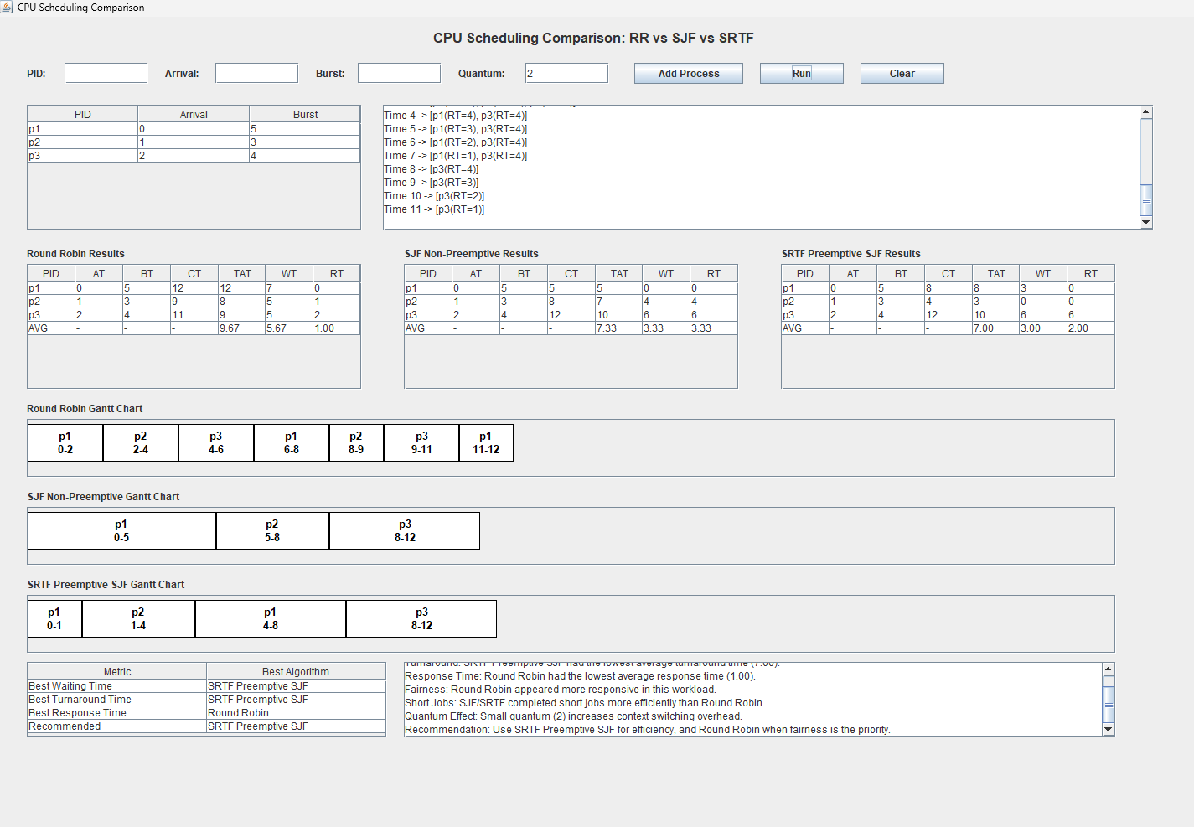

Scenario B: Short Jobs
This scenario demonstrates how SJF behaves efficiently when many short processes exist.
Quantum = 2
P1 Arrival = 0 Burst = 10
P2 Arrival = 1 Burst = 1
P3 Arrival = 2 Burst = 1 Result: SRTF achieved the lowest waiting time (0.67). SJF performed worst (WT=6.0) because it could not preempt the long P1 process.

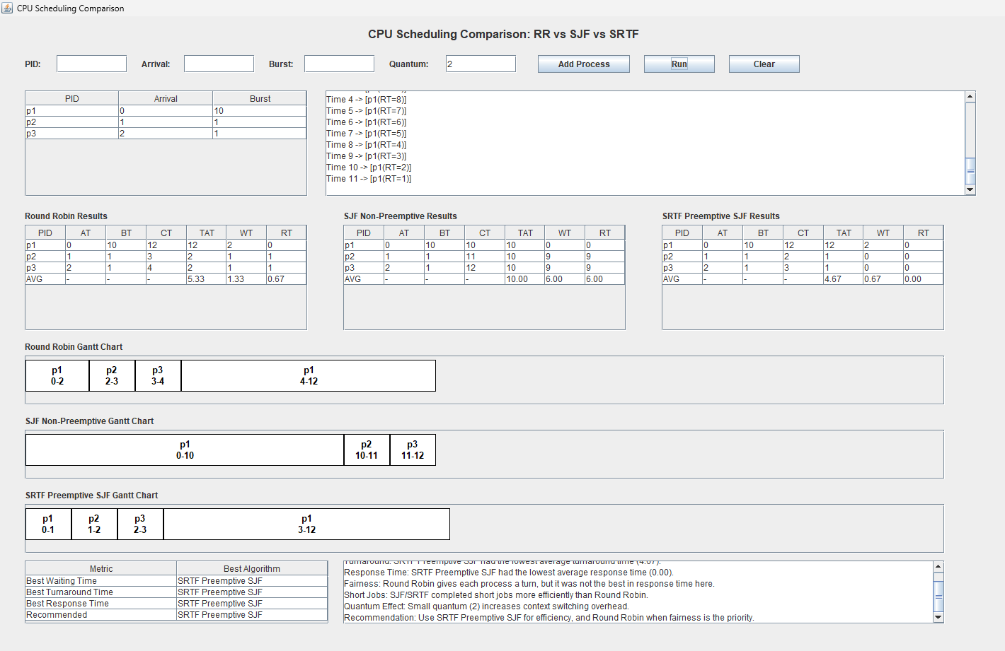
Scenario C: Long Job Sensitivity
This scenario shows how Round Robin distributes CPU time fairly between processes.

Quantum = 2
P1 Arrival = 0 Burst = 20
P2 Arrival = 1 Burst = 2
P3 Arrival = 2 Burst = 2 Result:Long process is delayed, showing starvation in SJF/SRTF.

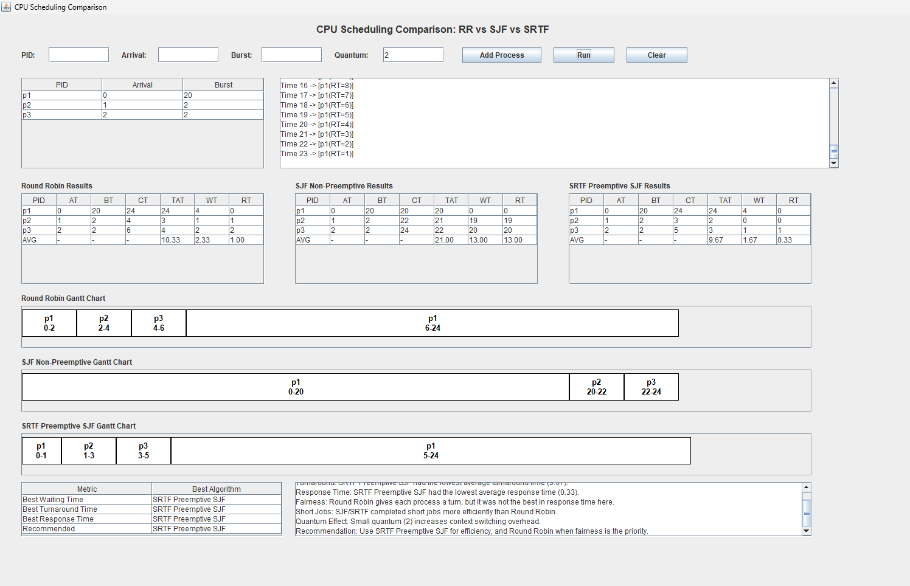

Scenario D: Fairness
This scenario compares the behavior when one long process competes with several short processes.
Quantum = 2
P1 Arrival = 0 Burst = 10
P2 Arrival = 0 Burst = 10
P3 Arrival = 0 Burst = 10
Result:Round Robin distributes CPU time equally and is more fair

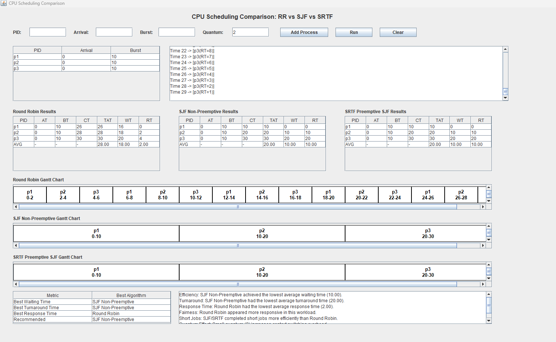

Scenario E: Input Validation
This scenario demonstrates input validation using invalid values such as negative burst time or invalid quantum.

Invalid Inputs:
Burst = -1
Arrival = -2
Duplicate PID
Quantum = 0
Result: The system correctly rejects invalid inputs.

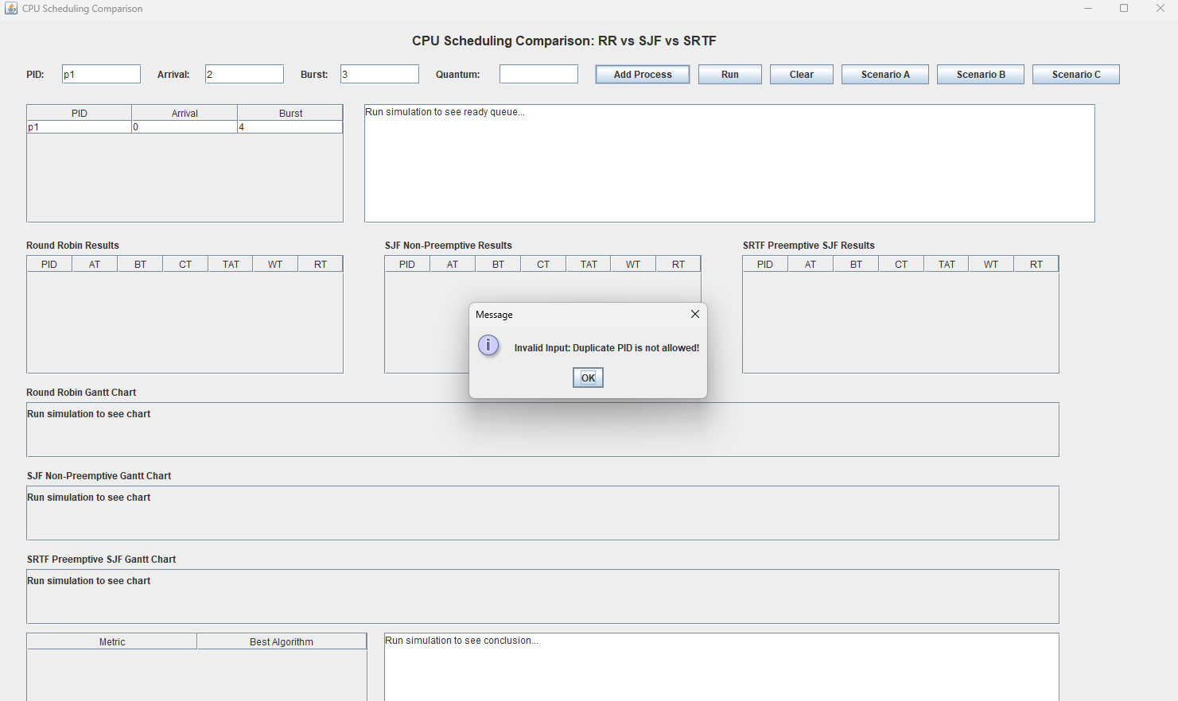

Comparison Between Algorithms
Metric | Round Robin | SJF
Fairness | High | Lower
Waiting Time | Usually Higher | Usually Lower
Response Time | Better | May Be Higher
Efficiency | Balanced | High

Required Analysis Questions
- Which algorithm gave lower average waiting time?
Answer: SJF usually gives lower average waiting time because shorter processes execute first.
- Which algorithm gave lower average response time?
Answer: Round Robin often provides better response time because every process receives CPU time quickly.
- Did Round Robin appear fairer?
Answer: Yes, because CPU time is distributed equally among processes using time slicing.
- Did SJF complete short jobs more efficiently?
Answer: Yes, SJF strongly favors short jobs and usually completes them faster.
- How did the selected quantum affect Round Robin behavior?
Answer: Smaller quantum increases context switching while larger quantum makes RR behave closer to FCFS.
- Which algorithm would you recommend and why?
Answer: SJF is recommended for efficiency and lower waiting time, while Round Robin is better for fairness and interactive systems.

Conclusion
The project successfully compared Round Robin and SJF scheduling algorithms using the same workloads. SJF achieved better efficiency and lower waiting time, while Round Robin provided better fairness and responsiveness between processes. The project also demonstrated the effect of time quantum and scheduling strategy on CPU performance.

